Answers
1. (a) Give the names of the following logic gates:
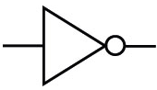 Name: NOT [1]

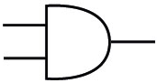 Name: AND [1]

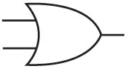 Name: OR [1]

(b) Draw the symbol for the following logic gates:
NAND gate [1]
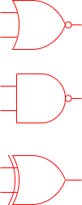
NOR gate [1]

XOR gate [1]

(c) Explain the difference between an OR gate and an XOR gate. [2]
An OR gate will output true if one or both inputs are TRUE (1). A XOR gate will only output TRUE if one of the inputs are TRUE / A XOR gate outputs FALSE if both inputs are TRUE. (1)

(d) Complete the following truth table for the circuit shown. [8]
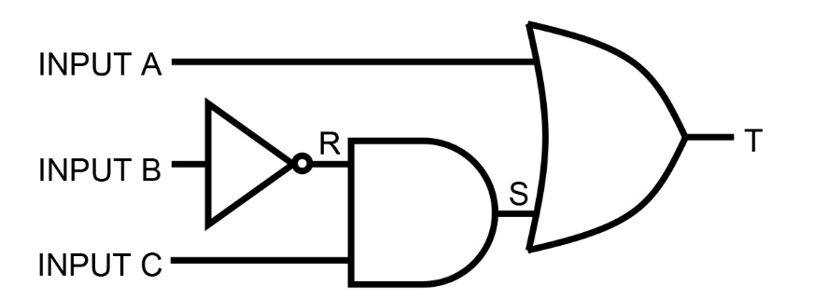

A | B | C | R | S | T
0 | 0 | 0 | 1 | 0 | 0
0 | 0 | 1 | 1 | 1 | 1
0 | 1 | 0 | 0 | 0 | 0
0 | 1 | 1 | 0 | 0 | 0
1 | 0 | 0 | 1 | 0 | 1
1 | 0 | 1 | 1 | 1 | 1
1 | 1 | 0 | 0 | 0 | 1
1 | 1 | 1 | 0 | 0 | 1
1 mark for each row
(e) Give the Boolean expression equivalent to the logic diagram. [2]
T = A OR (NOT B AND C)
A OR (1) (NOT B AND C) (1)
Brackets are required for second mark.

2. Tina has created a game that gives the user a score when the game finishes.
The highest score ever achieved by a player in the game is stored in a text file named
"Hi-score.txt".
When writing a program to read the high score, Tina first needs to open the file using the line of code:
OPEN "Hi-score.txt” FOR READ
(a) Explain what the syntax FOR READ means. [1]
The file is opened in read only mode / it can only be read from (1). This means that it is not possible to write to the file. (1)
(b) Complete the program so that the hi-score is read and stored in the variable
named HiScore. [2]
DECLARE HiScore : INTEGER
OPEN Hi-score.txt FOR READ
READFILE Hi-score.txt, HiScore
CLOSEFILE Hi-score.txt
1 mark for read.
1 mark for closing the file.
Allow marks for alternative syntax.
(c) The score the player achieves in the game is stored in a variable named PlayerScore.
Complete the program so that if PlayerScore is higher than the high score stored in HiScore, the PlayerScore will be stored in the file. [4]
DECLARE PlayerScore : INTEGER
IF PlayerScore > HiScore
THEN
OPEN Hi-score.txt FOR WRITE
WRITEFILE Hi-score.txt, PlayerScore
CLOSEFILE Hi-score.txt
ENDIF
1 mark for IF statement and correct conditional expression.
1 mark for opening file in write mode.
1 mark for writing the player score to the file.
1 mark for closing the file.
Allow different styles of syntax.
(d) Describe how the use of functions could improve the program code that you
wrote in parts (b) and (c). [2]
A function named GetHighScore could be made for part (b). (1) This would return the high score. (1) By using a function, the code can be re-used easily at different points in the main program (1). This helps when decomposing the problem, as the function solves the subproblem of getting high scores (1). A function SetHighScore could be used with the new score as a parameter (1). This would then save the score as in part (c).

(e) Give two reasons why it is important to use meaningful identifier names
in a program. [2]
You are less likely to make errors in the code. (1)
It makes the program easier to understand (1), debug/maintain (1).
3. The following function calculates a rail fare, based on the distance travelled. A discount of 10% is given for off-peak travel.
FUNCTION RailFare(distance, day, time)
IF distance < 5
THEN
RailFare 3.00
ELSE
IF distance < 12
THEN
RailFare 4.00
ELSE
RailFare 5.00
ENDIF
ENDIF

IF day = "Saturday" OR day = "Sunday"
THEN
RailFare 0.9 * RailFare
ELSE
IF time >= 10.00 and time < 16.00
THEN
RailFare 0.9 * RailFare
ENDIF
ENDIF
RETURN RailFare
ENDFUNCTION
What does the function return if it is called with each of the following statements?
(a) RailFare (4, "Monday", 8.00) 3.00 [1]
(b) RailFare (15, "Saturday", 14.00) 4.50 [1]
(c) RailFare (8, "Tuesday", 18.00) 4.00 [1]

4. The following function returns a value when called.
FUNCTION Checkval(value, low, high)
IF value < low
THEN
RETURN "Low"
ELSE
IF value > high
THEN
RETURN "High"
ELSE
RETURN "OK"
ENDIF
ENDIF
ENDFUNCTION
(a) (i) Name one parameter used by the program. [1]
value / low / high (1)
(ii) In the main program, the following statements are written.
OUTPUT "Please enter measurement: "
INPUT measurement
Write one or more statements which will call the function in order to check
whether the measurement is between 18 and 25, and output the result. [2]
result Checkval(measurement, 18, 25)
OUTPUT result
or
OUTPUT Checkval(measurement, 18, 25)
(b) Give two reasons why programmers use functions and procedures. [2]
Any two of:
A modular program which puts separate subtasks into functions and procedures is easier to understand and maintain (1).
Functions and procedures can be tested individually so the program is easier to debug (1).
A large complex program can be developed more quickly because different programmers can write different functions and procedures (1).
Functions and procedures can be re-used in several programs (1).
Functions and procedures may be used several times in the same program, but the code only has to be written once (1) which will reduce the number of errors made (1).

5. An estate agent keeps details of all the properties it has for rent.
An example of data from the table Rental is shown below.
PropertyID | Type | MonthlyRent | Beds | Furnished | DistanceToStation
1 | Apartment | £800.00 | 2 | Y | 0.3
2 | Semi | £475.00 | 2 | N | 1.5
3 | Apartment | £1150.00 | 3 | N | 0.5
4 | House | £1500.00 | 4 | Y | 0.2
5 | Apartment | £900.00 | 2 | Y | 0.3
6 | Apartment | £1250.00 | 3 | Y | 0.2
7 | Semi | £550.00 | 3 | Y | 2.4
8 | House | £600.00 | 3 | N | 0.6
(a) State the Property IDs of properties that will be found by the following queries:
(i) SELECT PropertyID
FROM Rental
WHERE MonthlyRent <= 550.00 OR Furnished = 'Y' [2]
1,4,5,6,7 (1)
2 (1)
(ii) SELECT PropertyID [1]
FROM Rental
WHERE Type = 'Apartment' AND DistanceToStation < 0.3
6
(b) Write an SQL query that displays the Type, MonthlyRent, Beds and Furnished
fields for all properties of type Semi or House which have at least 3 bedrooms. [4]
SELECT Type, MonthlyRent, Beds, Furnished
FROM Rental
WHERE (Type = 'Semi ' OR Type = 'HOUSE ') AND Beds >= 3
SELECT/FROM/WHERE keywords (1).
Correct fields (1).
Correct Boolean operators (1).
Correct brackets (1).

(c) What will the result of the following SQL query be? [3]
SELECT PropertyID, MonthlyRent
FROM Rental
WHERE Type = 'Apartment' AND Beds = 3
ORDER BY MonthlyRent DESC
6 £1250
3 £1150
Correct two fields (1).
Two records 6 and 3 (1).
Sorted in descending order by monthly rent (1).
(d) Write an SQL query that shows all details of all properties in the ascending
order of their distance from the station. [2]
SELECT *
FROM Rental
ORDER BY DistanceToStation ASC
Marks:
SELECT * FROM Rental (1)
ORDER BY DistanceToStation ASC (1)
Accept if ASC is not present as ascending is usually the default in SQL.
(e) Write an SQL query that finds the total number of properties that are
available for rent. [1]
COUNT(*)
FROM Rental
Accept COUNT(PropertyID)
Do not accept other field names being counted.
[Total 50 marks]

